b)

Transformer Design

We use 495-5251-ND as a core. Its material is N41.

Bsat is nearly 0.4T, which does not need excess amount of winding to avoid from saturation. To avoid from saturation, core has enough cross sectional area. Inductance factor of the core is 1.6 µH, which is also proper to reach at least 7.5 µH magnetizing inductance. Operating frequency of the converter is 100 kHz, which is in the optimum frequency range of the core. Core losses at 100 kHz is reasonable.

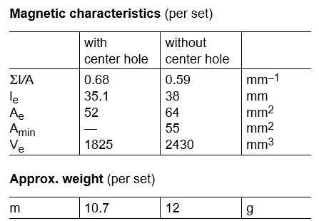

Figure : Core Properties

$N1>\frac{Vimax*Dmax*\frac{1}{fs}}{Bsat*Ae}$ (1)

From the equation (1), N1>2

Inductance factor of the core is 1.6 µH. In order to have less ripple than 40% on magnetizing inductance current (from part a), N1 should be 2.17, at least. For N1=3, Lm is equal to

$$3^2*1.6 µH=14.4 µH$$

By using the formula (2), N2 is 18.

(2)

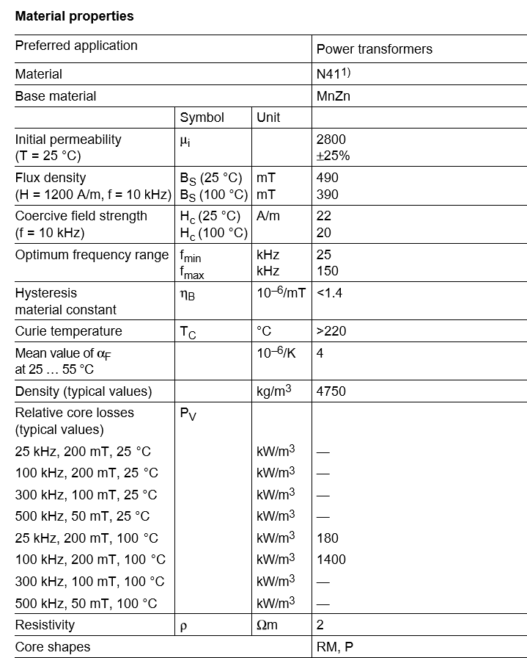

Figure :Core Material Properties

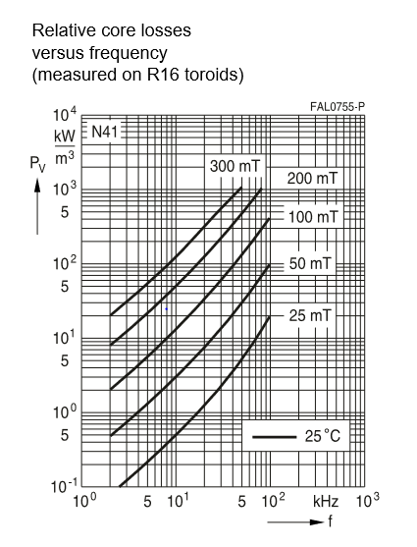

Figure : Core loss of the material